**Sample Questions for Exam 2**

Question 1

1. Discuss, with the help of a suitable example, the MiniMax strategy used to plan moves in a 2-person game from the perspective of the MAX player. You may assume a constant branching of 3 and that MAX looks just 1 move ahead.

*Here a 2-level tree is sufficient – no need to go beyond that as the procedure simply iterates beyond that*

Max

Min

12

23

6

5

17

9

3

4

19

6

5

3

6

1. Now suppose that Max decides to abandon his conservative strategy (i.e. the standard MiniMax policy) and gambles on the fact that Min being a human will not be able to rank moves accurately and will thus on the average make the move that gives the median score instead of the min score. What is the potential danger of such a MedianMax policy? You may use the same example that you used in part a) above with any modifications as needed to the scores.

*The danger with this strategy is that in situations where Min correctly assesses the move with the lowest score, then Max will make an incorrect choice. For example, see the rightmost node for Min in the next page.*

*Here Max incorrectly assumes that Min computes the minimum score at 14 whereas Min correctly computes it at 3. Min ends up making the left move whereas Max thinks it will be the middle move, thus causing Max to make the rightmost move which leads to a score of 3 instead of 6.*

Max

Min

6

12

23

5

9

17

3

14*

19

5

6

3

3

1. Apply alpha beta pruning to the game tree below and show the final state of the tree, indicating where the pruning has taken place.

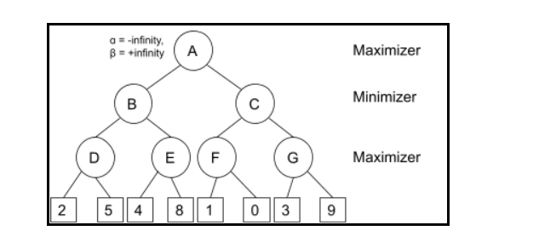



Question 2

Consider the following Sudoku game

|  |  |  |  |  |  |  |  |  |
| --- | --- | --- | --- | --- | --- | --- | --- | --- |
| 5 |  | 4 |  |  |  |  | 6 |  |
|  | 6 |  | 3 |  |  | 1 |  |  |
|  | 9 | 2 | 5 | 4 |  |  |  |  |
| 6 |  | 8 |  |  | 1 |  |  |  |
|  |  |  | 8 |  | 4 |  |  |  |
|  |  |  | 2 |  |  | 6 |  | 1 |
|  |  |  |  | 9 | 5 | 8 | 1 |  |
|  |  | 1 |  |  | 2 |  | 3 |  |
|  | 8 |  |  |  |  | 2 |  | 7 |

1. Consider the grid in the top right corner. Using the heuristic of minimum remaining values which cell(s) should be targeted first?

*RM(1,2) = {3,7,9}, RM(1,3) = {2,3,8,9}, RM(2,2) = {2,4,5,7,8,9}, RM(3,1) = {3,7}, RM(3,2) = {7,8}, RM(3,3) = {3,8} (RM stands for remaining values)*

**Note: The original version incorrectly mentioned top left corner instead of the top right corner**

1. The results of a) indicate a tie between 3 cells. How will you break the tie? Hint: Pick the cell (variable) that results in the most constraints on remaining variables and look further than the grid itself.

*Out of the tied variables the cell (3,3) results in constraining 6 variables in column 3 as opposed to 5 variables for cell (3,2) and 4 variables for cell(3,1) (as we eliminate rows and grids, since all 3 cells have the same row and the same grid). Thus cell (3,3) will be the tie breaker.*

Question 3

1. Design a neural network to solve the Boolean AND operation. Note your design should include the input, hidden and output layers and the weights between the neurons in each layer. You should also compute the weights of the connections in each layer as well as the threshold value used in the hidden layer. Use the Relu activation function instead of the sigmoid discussed last week. The Relu function is given by Relu(x) =Max(0,x) for all x in the range -inf to +inf.

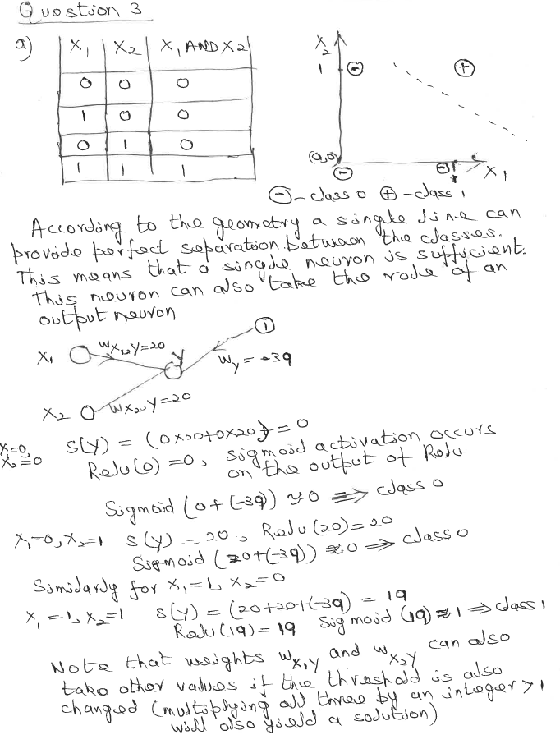

1. Repeat the same process for the XOR Boolean operation. What is the most significant difference with the network that you proposed in a) above?



1. The number of patterns in the training dataset (i.e. the Truth table in this case) does appear to be a pointer to the number of hidden neurons. How this concept of the number of patterns help us in solving a real-world problem such as disease diagnosis?

*When we generate a decision tree that does not overfit, each leaf node represents a cut in the feature space. Each cut corresponds to a hidden neuron. Thus we can use the number of leaf nodes L as an estimate for the number of neurons in the hidden layer. This value can be further refined by tuning.*

Question 4

Answer the following questions based on the Bayes net given below.

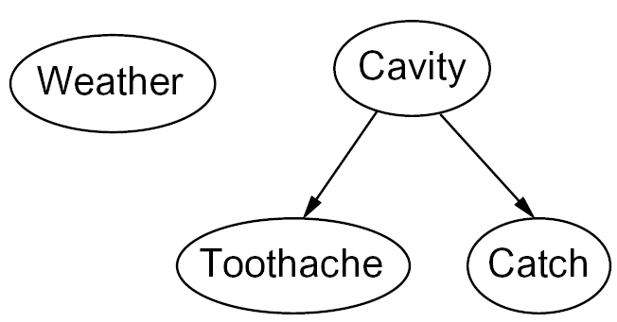

1. List 3 items of information that you can infer from the net given above. Briefly justify your answer.

*(1): Cavity and Toothache are dependent on each other, (2) Cavity and Catch are also dependent on each other, (3) Toothache and Catch are independent of each other.*

1. If P(c+)=0.3 and a dentist’s records show that P(t+,c+) = 0.27, P(ct+,c+)=0.3

and P(ct+) = 0.6 where c+, ct+ denotes the occurrence of a cavity and catch respectively, work out P(t+,c+, ct+), i.e. the probability of a toothache, cavity and catch occurring together.

*P(t+|c+ ) = P(t+,c+)/P(c+) = 0.24/0.3 = 0.8*

*Likewise, P(ct+|c+) = 0.12/0.6 = 0.2*

*Now P(t+,c+,ct+) = P(t+|c+)*P(ct+|c+)*P(c+) = 0.9*0.5*0.3 = 0.135*

1. Now imagine another factor called Infected Gum (IG) is added to the network with a connection to Toothache with P(ig+, t+)= 0.12 and P(ig+)=0.16. Work out the probability of getting a toothache in the presence of a cavity and infected gum.

*P(t+|ig+ ) = P(t+,ig+)/P(ig+) = 0.12/0.16 = 0.75*

*Now P(t+,c+,ig+) = P(t+|c+)*P(t+|ig+)*P(c+)*P(ig+) = 0.9*0.75*0.3*0.16 = 0.0324*

**Note: Parts b) and c) have been changed from the original version; I have also used the probability notations used in the slides for the sake of consistency.**